**SMDG Plenary, Process Meeting No. 68 |MINUTES**

**Wednesday 5th October 2016/ Plenary/ Xvela |Hamburg**

**Thursday 6th October 2016/ Process/ Arthur Touzot |Hamburg**

|  |  |  |  |  |  |  |  |  |  |  |  |  |  |  |  |  |
| --- | --- | --- | --- | --- | --- | --- | --- | --- | --- | --- | --- | --- | --- | --- | --- | --- |
| |  |  | | --- | --- | | **Meeting called by** | SMDG Committee | | **Type of meeting** | Plenary Meeting | | **Chairman** | Bruis van Driel (new) | |  | Simon Spoormaker | | **General Secretary** | Arthur Touzot (new) | |  | Gerry Endenburg | | **Host** | XVELA | | |  | | --- | |  | |

# Agenda topics

**ADMINISTRATION** Bruis van Driel / Simon Spoormaker **Page 2**

Arthur Touzot / Gerry Endenburg

**XVELA** Manuel Perez **Page 3**

**VGM & VERMAS** Michael Schröder /Jost Müller **Page 4**

**BAPLIE/MOVINS** Jost Müller **Page 5**

**BAPLIE Viewer Tool** Marc Jordens **Page 6**

**DMR’s for Cut Off Dates (IFTSAI)** Michael Schröder **Page 7**

**CONTAINER MESSAGES** Paul Wauters **Page 8**

**CODELISTS** Michael Schröder /Jasmin Droenner **Page 9**

**TPFREP** Michael Schröder **Page 10**

**EXIS** James Douglas Page 11

**BIC** Jorn Heerulff **Page 11**

**Intercompany Com and Bus Process (C**ICBP)Bruis van Driel **/** Arthur Touzot **Page 12**

Ann Christin Fröhmcke **Page 13**

**Future Meetings/AOB/Closing** Bruis van Driel **Page 14**

**Executive Summary:**

The 68th SMDG meetings convened in Hamburg from the 04th till the 06th of October gathering up to 34 industry experts hosted by XVELA (4,5) and Arthur Touzot (6): Sub group, Plenary, Process

A new management has been elected assuring a new era to build on the strong foundation of the 3 decades of the work from previous leadership. New SMDG Chairman is Bruis van Driel, and new SMDG General secretary is Arthur Touzot

The core of the debate was on the EDI and process implementation of the VGM. The latest UN/EDIFACT format VERMAS has achieved its purpose of enabling VGM to be measured and reported accordingly along the supply chain utilizing updated legacy format (BAPLIE 2.2 and above, COPRAR…).

Nevertheless, the respect of the standard as defined in Official UN documentation is yet to be improved by the different stakeholders linked to the maritime logistic chain.

Further actions are to be defined for implementation by the renewed subcommittees with the addition of a specific subcommittee on Communication and business processes for all of whom we invite industry stake holder to participate actively.

Recommendations were also drawn for the industry to update their systems, trainings, processes with the correct and approved format especially for BAPLIE 2.2 and VERMAS 1,0

The next meeting is schedule to be convened in beginning of march 2017, in Genoa, hosted by MSC upon confirmation.

Have a good reading

Bruis van Driel Chairman of SMDG

Arthur Touzot Secretary General SMDG

# ADMINISTRATION

**Presentation | Bruis van Driel/ Simon Spoormaker; Arthur Touzot/ Gerry Endenburg- Approved**

1. **New Chairman and General Secretary have been elected:**

Ship-planning Message Design Group (SMDG), a non-profit organization run by and on behalf of organizations in the maritime industry, has, in its 68th plenary meeting, elected Bruis van Driel (APM Terminals) as Chairman and Arthur Touzot (ATSEA consulting) as Secretary General.

1. **Updated Mission proposal to include Common Intercompany Communication and business Process.**

*In italic are addition or correction*

SMDG develops and promotes UN/EDIFACT EDI-messages for the Maritime Industry and is an official *Global* User Group, recognised by the UN/EDIFACT Board.

*SMDG is also a collaboration and services platform for the entire Maritime industry. We bring together supply chain professionals and technology experts to create standards, develop best practice and common intercompany communication and business process to bring the industry to a higher level of efficiency across the maritime logistic chain.*

1. **Updated Format of the SMDG meetings from 2 day to 3 days to include the CICP:** The SMDG meetings format has been enhanced by the addition of a permanent 3rd day dedicated to Common Intercompany Communication and business Process. The format will now be: 1st day Subgroup meeting to wrap up actions and materials produced between both bi annual sessions: the 2nd day will be the plenary sessions will be used to communicate on the achievement and start the nest action plan with the input of the full SMDG attendance. The 3rd day will be dedicated to the CICBP. It will address the issues of the business implementations and process to enable efficient and accurate usage of the EDI format and industry feedback on regulation implementations or business needs (VGM, COPRAR exchange within alliances, TPFREP…). It will also address recommendations for IT providers for their own development road map to insure proper and efficient systems integrations through EDI et al. This will enable the SMDG to move forward on the implementation actions plan, define the business requirements of the industry for the next SMDG bi annual general meetings, implement further subgroups work.
2. **Updated Subgroups to include Common Intercompany Communication and business Process:**

Subgroups chairman are details below in the management board. Sub group members are detailed in each member are detailed in each subgroup meeting minutes: Chairmen of subgroups are,

## Objectives – General Management Board

The general management objectives are to extend the accurate use of EDI format and improve SMDG documentation, compliance tools (ex GEFEG), and recommendation release to enable industry efficiency. Supply chain industry efficiency is to be matched with Message chain efficiency. For this purpose, we are dedicated to also reach out to our partners not yet attending and/ or represented (Asia, main It providers or platform such as INTTRA, SAP, GT Nexus, Solverminds….) and also to other shipping or supply chain stakeholder (Breakbulk, roro, rails, depos), extend the application to breakbulk for VGM declaration. This should enable enhancement of the digitalization to gain access to big calculations

## General Management Board

SMDG Chairman is Bruis van Driel, SMDG General secretary is Arthur Touzot

Subgroup Chairmen are:

Michael Schröder (HLL) for VERMAS, and TPFREP subgroups, Jost Müller (Interschalt) for BAPLIE and MOVINS subgroups, Paul Wauters (PSA/COSMOS) for Container Messages and INVOIC subgroups, Patrick Straka (Maersk) for Codes management subgroups, and Ann-Christin Fröhmcke (CMA CGM) for Common Intercompany Com and Bus Process (CICBP).

## Action

**Chairman:** make press release for change of management, scope and organization update

**General secretary:** prepare minutes meeting for SMDG board approval, set up the work environment and administration including, collaborative platform, web sites, by 15/11/2016 for general communications and subgroup meeting work. Trials on egnyte and Gotomeetings

**Chairman General secretary:** Prepare for next SMDG meeting. Proposal of agenda with Subgroup chairmen

**Subgroups chairman**: confirm sub groups members, confirm minutes’ meetings and prepare/ do work for next SMDG

**Chairman and General secretary:** co-organize with host next SMDG meeting

# XVELA

**Presentation | Manuel Perez - Approved**

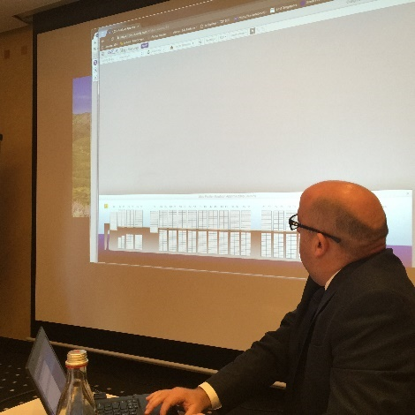





Presentation of Manuel Perez on XVELA. XVELA is a cloud base platform part of Cargotec group (NAVIS, XVELA, INTERSCHALT, M +B) aiming to streamline communications between carriers and Terminals.

Mr Perez presented some functionalities of terminal/ carrier comparison baplies, transcoding tables for loc/ carrier, codes, logs of communications

One of the aim of XVELA is to bring also terminal operation follow up visibility to carriers by COARRIES. Crane Intencities/ crane split

XVELA is also looking at Port authorities’ communities that seek a better view over containership operations within their areas and tracking of such between areas.

## Objectives/Comments

Further needs on user interface exchange between terminals and carriers in real time were highlighted by members to further include crane split/ crane intensity display and bay views.

SMDG community is always interested to have update roadmap and demonstration of IT, Service provider tools

# vERMAS & VGM

**Presentation | Michael Schroeder- Approved**

## Reasons for developing the VERMAS as a completely new message

1. **New processes might be needed**: There are new process steps that are not covered by existing message types. For example, reporting from a weighing station to the shipper, or the weight from the terminal to the carrier or from the carrier to the shipper.
2. Different timing for weight transmission in current messages. In many cases, the existing messages are sent at a different time than the VGM is known or is required. The existing messages are sometimes sent too early or too late for transmission of the VGM.
3. One new message is easier than changing many existing messages Shippers, carriers and terminals need to change a large number of message versions, on a fixed deadline. Many of them find it easier to implement one new message for the special purpose of VGM reporting than upgrading many existing message versions and test simultaneously with many EDI partners.
4. Message identification determines the purpose. The receiver can detect the purpose (VGM update) from the message identification VERMAS. He does not have to go into the message to detect the function.

## Objectives/Lessons Learnt – Working Group

Speedy progress SMDG has reacted quickly on the new requirements, long before most stakeholders even realized the regulations.

* **Good cooperation**: SMDG and UN/CEFACT have jointly developed and published a completely new Edifact message structure and the implementation guide in a very short timeframe.
* **Successful development of a new EDI format:** Since the start of VGM requirement on 1st July 2016 the VERMAS has been implemented and used by innumerable parties from all sectors of the maritime industry. The VERMAS satisfies the needs of all stakeholders and it has become the world standard for VGM reporting. Only odd critical voices were heard.
* **Public awareness of SMDG**: The SMDG expertise for VGM was taken for granted and not doubted. SMDG became a focal point for information around VGM transmission requirements. The public awareness of SMDG as standardization organization grew considerably.
* **Edifact still going strong EDI in the maritime industry** is still centered on Edifact messages. There was no doubt that the VERMAS should be developed in the Edifact framework and not in other formats such as for example XML, JSON or Webservice. All stakeholders are operating Edifact environment and could therefore implement the VERMAS easily.
* Some stakeholders are still using a provisional version of the specification 0.4 and should move to the actual approved UN/EDIFACT one the 1.0. the differences are well documented and explained
* VERMAS message not to be used as handling instruction to order weighting
* COPARN to be used as preferred means for weighting order within the process with the concerned stakeholder.
* COREOR require new business process and is not yet enough implemented

| Actions | Working Group | Deadline |
| --- | --- | --- |
| Only use 1.0 to go forward   * 1.0/23.6.2016 Final MIGVersion * Parameters/Shipping Line * #1Qualifier * In case of enhancement requests on the VERMAS, please  contact the working group chairman.  Recommendation:  * 1.0/Version only on the site * COPARN to be used for weighting orders   [1-VERMAS SMDG Meeting HAM 2016-10-05.pdf](http://www.smdg.org/assets/assets/1-VERMAS-SMDG-Meeting-HAM-2016-10-05.pdf?) | Michael Schröder (Chair)  (HLL)  Jost Müller  (Interschalt)  Paul Wauters (PSA)  Stefano Ottonello (MSC)  Yoshi Kito (Ind Cons) | April 2017 |

# BAPLIE/MOVINS

**Presentation | Jost Müller- Approved**

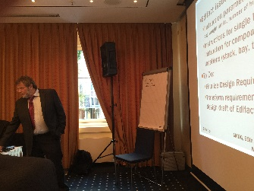The past year of the subgroup BAPLIE/MOVINS has been busy to provide VGM-enhanced BAPLIE versions 2.2 and 3.1. Many IT solution providers focused implementation of BAPLIE 2.2, but there is an increasing interest in BAPLIE 3.1.

Terminals, lines and on-board instruments process information for indicating whether a container’s gross mass has been verified or not. (Some updated implementations even use VGM qualifiers in messages incorrectly claiming to be version 2.0 or 2.1.) Capabilities for transmitting additional VGM documentation in versions 2.2. and 3.1 are rarely used.

The latest MIG revisions 2.2.1 and 3.1.1 can be downloaded from SMDG website.

Now after interruption by the VGM implementation, the regular work on development for a major upgrade of message MOVINS should continue.

## Objectives / Lessons Learnt – Working Group

**BAPLIE**:

Some BAPLIE messages have been observed which confusingly transmit both qualifiers *verified gross mass* and a *gross mass without verification.* The MIG should have explained more clearly how to use these qualifiers.

There has been a question on how to transmit information on subsidiary risks in the DGS segment. The MIG for versions 2.x is not very clear on that. We should improve/harmonize explanation as it is done in version 3.x .

These has been the question on how to transmit the position of gear boxes. SMDG members supported this requirement because of the moves on arrival and Suez canal declaration. However there is no proposal yet. It is unclear how to express an equipment size/type for “gear boxes”.

**MOVINS** version 3 objectives:

* + Include features introduced with BAPLIEv3 -- Support new business demands
  + Reduce need for additional communication about stowage instructions
  + Structure MIG according to principles of BAPLIEv3 – allow for message validation in SMDG portal
  + Some catch words: stack weight, stack height, container’s max. stacking weight

| Actions | Working Group | Deadline |
| --- | --- | --- |
| Next working group meeting: 14.December 2016 at 15:00  in Hamburg, Hapag-Lloyd office & conf.call  Finalize MOVINS Design Requirements  Transform requirements into design draft of Edifact message  Study the validation portal Recommendation: It has been notified by SMDG Ocean carrier and terminal members that  some vessels were still not updated with the proper version to read at least BAPLIE 2.2 containing VGM. All vessel owners are requested to upgrade their loading computers.  SMDG Ocean carrier require Terminals not yet capable to generate BAPLIE 2.2 to update their systems  [2 -BAPLIE-MOVINS-minutes.pdf](http://www.smdg.org/assets/assets/2-BAPLIE-MOVINS-minutes.pdf?) | Jost Müller (Chair)  (Interschalt)  Peter Horstkorte  (interschalt)  Michael Schröder  (HLL)  Henrik Monberg Carlsen  (Kokumsonic)  Heidi Stemler  (HHLA)  Jasmin Drönner (Eurogate)  Paul Wauters (PSA)  Jeroen Muis (Copas)  Manuel Perez (XVELA) | April 2017 |

# BAPLIE Viewer tool

**Presentation | Marc Jordans - Approved**

**RoadMap For 2016**

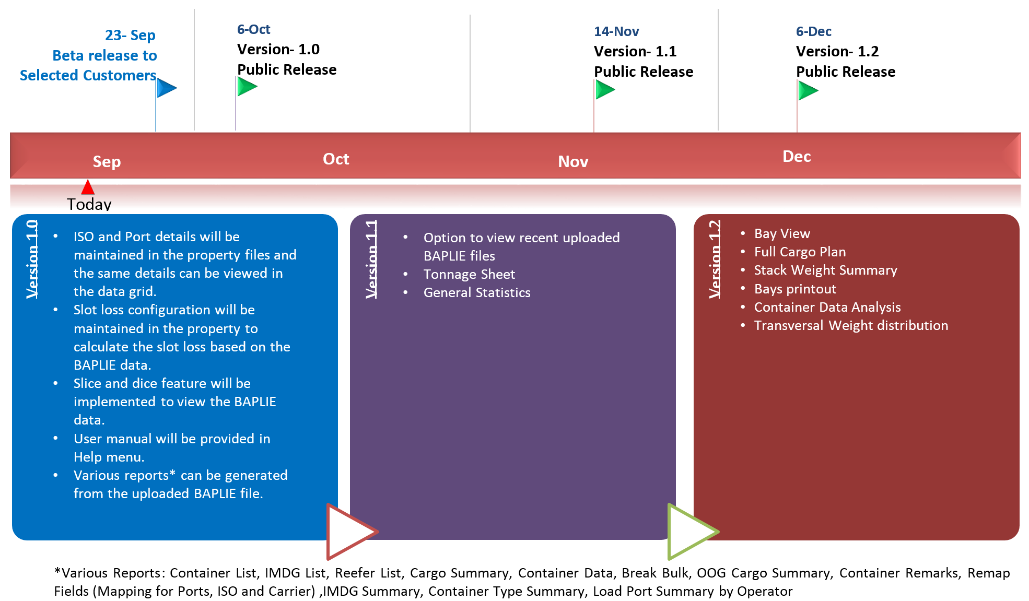

| Objectives |  |  |
| --- | --- | --- |

Context is that the industry is looking for new tools with which to read VGM enabled files (BAPLIE version 2.2 mainly). Baplie Viewer Tool from Solverminds is one such standalone tools with a very reactive development.

It can be downloaded here: <https://www.solverminds.com/svm-baplie-viewer/>

Other tools are also existing such as Baplie Viewer (web base) or part of the package of other IT solutions (Stowman, CASP..).

This important as per implementation of VGM to enable check and comparison from the different stakeholder. Agents, terminals, on board, partners…port authority

| Actions | Working Group | Deadline |
| --- | --- | --- |
| For Information Only  [3- SVM BAPLIE Viewer Roadmap.pdf](http://www.smdg.org/assets/assets/3-SVM-BAPLIE-Viewer-Roadmap-.pdf?) | Not Applicable | N/A |

# iftsai -dmr’s for cut off dates

**Presentation | Michael Schroeder - Approved**

Cut-off dates (closing dates) are typically agreed between a shipping line and a terminal. They denote the latest arrival time at the gate for accepting cargo to reach a certain vessel. There can be different cut-off times for general cargo, hazardous cargo, out of gauge etc.

* Cut-off times are transmitted in IFTSAI as part of the vessel schedule, and in IFTMBC with the booking confirmation from the carrier to the shipper.
* During the VGM implementation it became clear that a new cut-off time for the VGM was needed. In that course it became obvious that the existing qualifiers for other cut-offs are insufficient and incomplete.
* Therefore, we are proposing in total five DMRs for new qualifiers.
* This work could also be transferred to COPINO

| Objectives/Actions |  |  |
| --- | --- | --- |

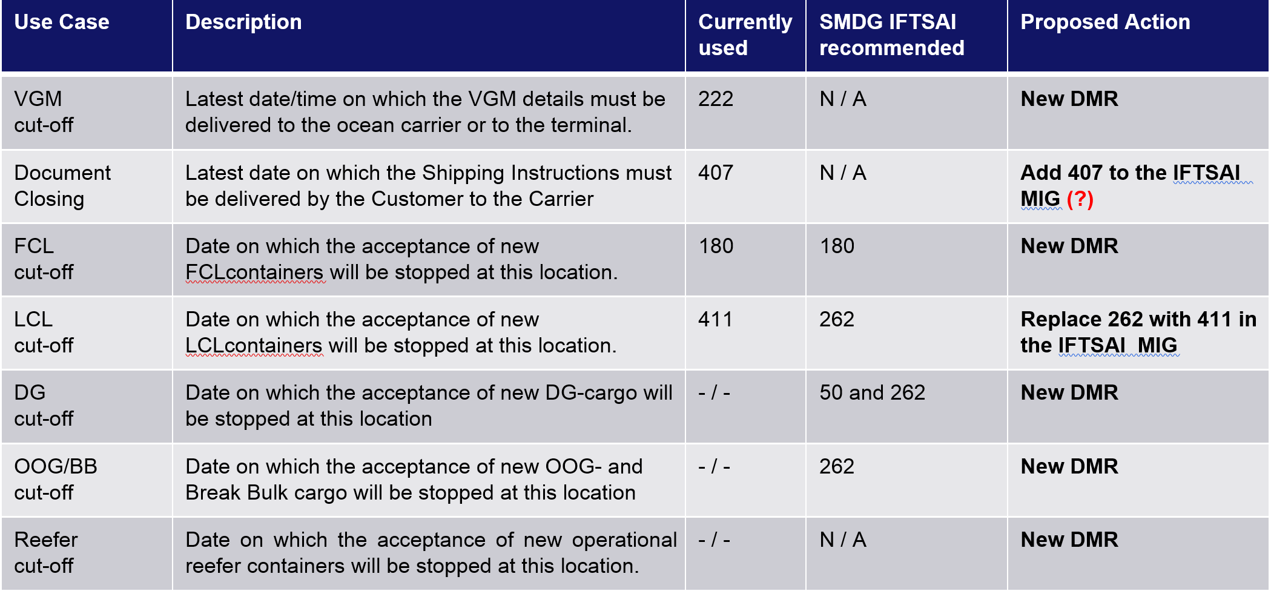

| Actions | Working Group | Deadline |
| --- | --- | --- |
| The new DMRs will be submitted by Michael on behalf of the SMDG to the UN/CEFACT Transport&Logistics group.  Publication is intended for D.17A directory release. Recommendation: [4- DMR cut-off dates SMDG Meeting 2016-10.pdf](http://www.smdg.org/assets/assets/4-DMR-cut-off-dates-SMDG-Meeting-2016-10.pdf?) | Michael Schröder (Chair)  (HLL)  Marc Jordens (HSD)  Bruis van Driel (SMDG)  Patrick Straka (MSK)  Hans Vlasblom (ECT)  Boudewijn de Kievit (ECT) | April 2017 |

# container messages

**Presentation | Paul Wauters - Approved**

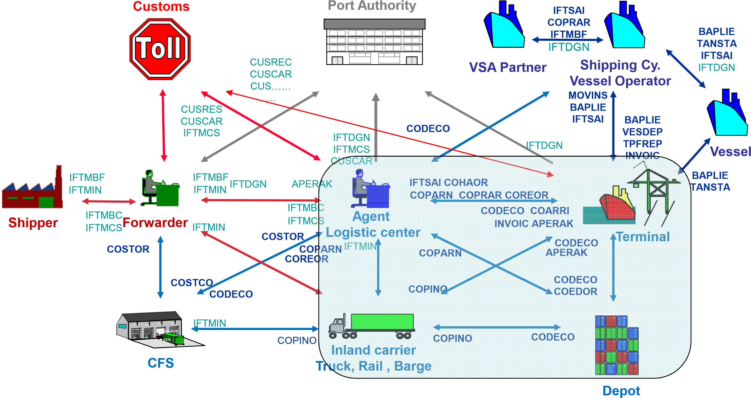**Principle**:

Generate one base structure

Individual EDI messages pick the necessary segments and keep the base order

**Benefits:**

Better quality messages

Easier maintenance – manual

Reusable

| Objectives/Lessons Learnt – Working Group |  |  |
| --- | --- | --- |

Issues Identified

* Indication of Damage Condition (DAR)
* Current Equipment Condition (ABS) - report on the current condition and/or status of a container, including confirmation of HAN
* Handling Instructions (HAN) - instructions on action to be taken
* A new message might be necessary for reefer monitoring following the process taken by the VERMAS

Insert of VGM and alignment of standrads between

* COHAR MIG to include weighting order
* Standardization for D95B and D00Bfor COPRAR and COPRAN
* DGS – dangerous goods in D 95B are not enough and linited to 9. Authority requires full disclosure of DGs so that container >9 Dg ref inside can be handled.
* Improvement is needed on a general basics on qualifiers
* Generic message structure should be kept along the different messages.
* Some clarifications in documentations is also needed as for example the LOC codes that could be confusing and misinterpreted especially for Transshipment on different terminals with inland transfer
* Clarification (by samples – cfr. BAPLIE)

| Actions | Working Group | Deadline |
| --- | --- | --- |
| Proposal for the next SMDG meeting on Reefer message  Proposal on standardization of D95B and D00Bfor COPRAR and COPRAN Recommendation: [5- SMDGContainerMessagesHamburg2016.pdf](http://www.smdg.org/assets/assets/5-SMDGContainerMessagesHamburg2016.pdf?) | Paul Wauters(chair)  (PSA)  Harald Lange (ContCargo)  Patrick Straka (MSK)  Jeroen Muis (COPAS)  Bruis van Driel (SMDG)  Stefano Ottonello (MSC)  Yoshi Kito (Ind Consultant) | April 2017 |

# code lists

**Presentation | Michael Schroeder / Jasmin Droenner - Approved**

## Code lists maintained by the SMDG are:

* Master Liner Codes
* **Terminal Facility Codes**
* Handling Codes (introduced with BAPLIE 3.0)
* Blocking Codes (introduced with BAPLIE 3.0)
* ATT Codes (introduced with BAPLIE 3.0)
* Delay Codes (IFTSAI and TPFREP)
* SMDG Codes on VGM Information (new)

**Main purpose:**

Main purpose of this sub group is to stream line the edition and correct use of UN LOC code and EDI / SMDG code lists from ISO code boxes (in cooperation with BIC) to handling codes to locations codes including terminal codes. Different stakeholders are using different codes from their internal systems to their communication systems creating a lot of work of Transcoding tables between internal systems and external. Part of it is due to the either the lack of UN clarity or UN codes with the different locations, part of it is due to legacy practices that needs industry recommendation to evolve and become efficient.

Indicate the discharge location of a container if a vessel calls at multiple terminals within a port

For example, Hamburg port DEHAM with HHLA terminals CTA and CTB…

**Identification of terminals:**

Unique by a combination of UN/LOCODE and Terminal Code to streamline the industry on this use.

Ocean carriers are sometimes producing their own norms, internal coding systems adding 3 or more letters to the 5 Un loc code. Those are not aligned between alliance partners and should be avoided.

**Container ISO codes**

Needs better requirements and documentations for proper follow up and application.

See also the BIC Page 11

| Objectives/Lessons Learnt – Working Group |  |  |
| --- | --- | --- |

New column in the Terminal Facility Code list: “alternative UN/LOCODE” (only on request). Why? Different parties may use different valid UN/LOCODES. Big terminals are notifying to the ocean carriers their codes. However, they do not always correspond to the geographical location. Ex NLRTM, for Rotterdam maasvlakte 2 i/o NLMSV. MTMLA for Malta free port.

China terminals are also using Metropolitan codes.

**Terminal Facilities List**

Example:

Virginia International Gateway: USORF = Norfolk is the metropolitan code while USPTM = Portsmouth is the geographical location. Both are in use by different parties.

| Actions | Working Group | Deadline |
| --- | --- | --- |
| New Layout (as per decision on SMDG meeting in April 2016 in Copenhagen):  New column: “alternative UN/LOCODE” (only on request) Default proposal prior to recommendation Terminals to contact with Chairman of the subgroup or SMDG management and indicate how they wish to proceed. What UN/Locode code to refer them, the metropolitan or the geographical location. Recommendation: [6-SMDG_Code_Lists_Hamburg 2016-10-05.pdf](http://www.smdg.org/assets/assets/6-SMDG-Code-Lists-Hamburg-20161004.pdf?) | Patrick Straka (chair)  Jasmin Drönner  (Eurogate)  Mario Scimone (SCT)  Ricardo Wagner  (Compta Emerging Business)  Emmanuel Odartey (TEC)  Marc Jordens(HSD)  Arthur Touzot (SMDG) | April 2017 |

# TPFREP

**Presentation | Michael Schroeder - Approved**

**TPFREP - Terminal Performance Reporting EDIFACT Message**

TPFREP 3.0 based on D.00B directory was developed by SMDG several years ago. Hapag-Lloyd started implementation in 2008.

Currently 86 terminals worldwide are sending the EDI message version 3.0

TPFREP 4.0 based on D.11B directory was published by SMDG in October 2012. Summary of Changes:

• Improved message structure.

• All temporary qualifiers and codes replaced by codes officially approved by UN/CEFACT.

• Out of Gauge and Temperature Controlled cargo can be reported separately.

• Breakbulk cargo per Operator can now be reported.

As per October 2016, some 20 terminals worldwide are preparing TPFREP 4.0 implementation. Productive usage is slowly increasing. ECT Rotterdam and Cartagena ready to go live.

TPFREP as describe above and within a certain carrier / terminal process is not only be used for Terminal performance reporting, but also for stream lining Carrier and terminal financial relationship. Few carriers have been using it such as HLL, CMA CGM, HSD, UASC…but further work by the subcommittee should be done to with the TPFREP Subcommittee to:

* Define business requirements for the evolution required
* Define motivation to have main terminal groups applying it
* Define proper inventory of actual business process to emit the format and target business process for the IT/ solution provider to develop the necessary common tools in their roadmaps.

| Objectives/Lessons Learnt |  |  |
| --- | --- | --- |

* Awaiting the first implementations of TPFREP 4.0 Gain experience, see whether new requirements arise from productive usage.
* Enhance the Excel reporting format with the additional data elements from version 4.0 (Reefer, Breakbulk/OOG, … ) Remark: The Excel format is not provided by the SMDG.
* Discuss the new requirements in the working group, check whether the terminals can provide the requested level of detail.

| Actions | Working Group | Deadline |
| --- | --- | --- |
| Find solutions, agree in the working group and submit the respective DMRs.Eventually develop a message implementation guide version 4.1 (currently, October 2016, development is postponed because many resources were allocated to VGM projects).Recommendation: [7-TPFREP SMDG Meeting Hamburg 2016-10-05.pdf](http://www.smdg.org/assets/assets/7-TPFREP-SMDG-Meeting-Hamburg-2016-10-05.pdf?) | Michael Schröder (Chair)  (HLL)  Jeroen Muis, (Copas)  Heidi Stemler, (HHLA)  Marc Jordens, (HSD)  Patrick Straka, (MSK)  Boudewijn de Kievit, (ECT)  Emmanuel Odartey, Ghana (TEC)  Arthur Touzot, (SMDG)  Manuel Perez, (XVELA) | Unknown |

# BIC

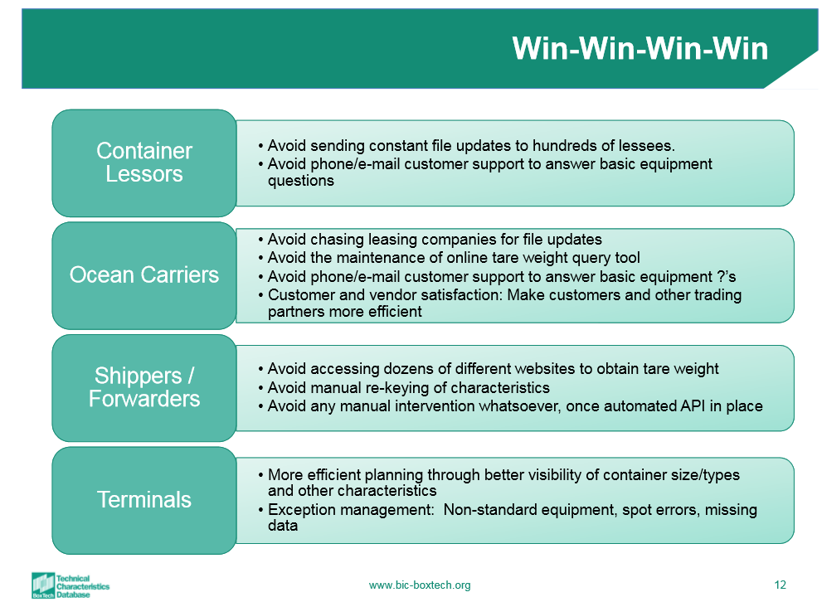**Presentation | Jorn Heerulff BoxTech - Approved**

Jorn Heerulff presented The Bureau International des Containers BIC and Boxtech

They are older of the ISO rules under UN/IMO for:

* Technical data on container iso 1496
* container identification number and marking of container iso 6346
* container status ( damage..) 9897
* …..

ISO 6346/amendment 3 contains enhancement for reduce stacking and racking capabilities.

The amendment can be downloaded here:   
<http://www.iso.org/iso/home/store/catalogue_tc/catalogue_detail.htm?csnumber=59778>

New boxes are produced with new codes while old one stay with their present codes

BIC would like to call upon SMDG members to review documentation for group 2 work on Equipment identification to adapt codes to new type size and industry requirements, such as door openings…. See Codelist Chairman/ subgroup to participate

Boxtech can be a reference for the tare weight VGM. The weight of a container (transport equipment) can slightly change in its life time depending of the maintenance.

**BIC + SMDG cooperation**  
The BIC maintains a code list for inland and sea port depots and repair shops. This list partly overlaps with the SMDG Terminal Facility code list. It is intended to harmonize the two code lists. The code list working group will address this.

[8-Boxtech TCD_SMDG_Oct 2016.pdf](http://www.smdg.org/assets/assets/8-Boxtech-TCD-SMDG-Oct-20161.pdf?)

# exis

**Presentation | James Douglas EXIS - Approved**

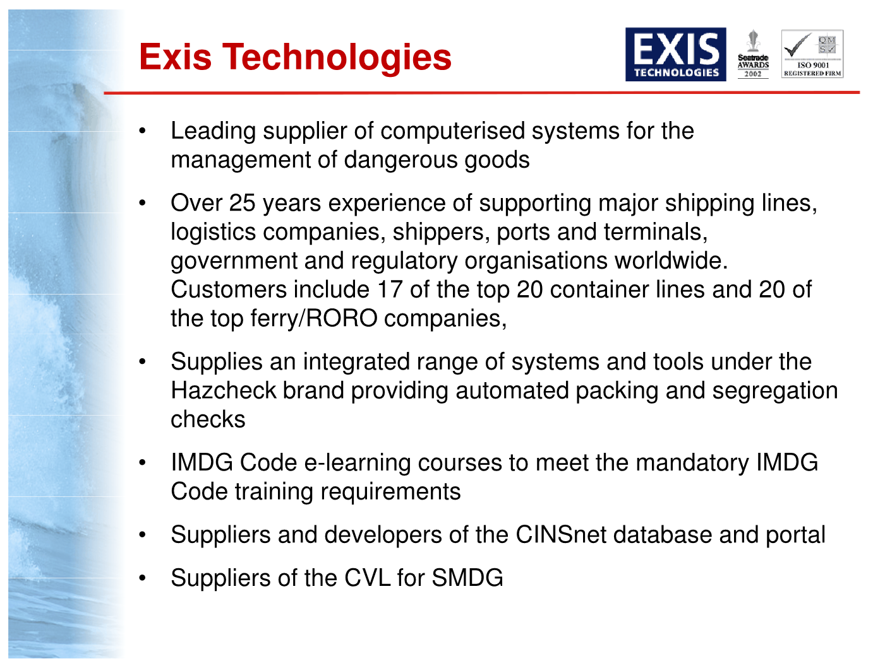James presented Exis as per slide on the right

Exis mention their IMDG database including also port restrictions and the library of tools available to the industry.

They also produce a VGM e-learning courses.

Those have been promoted by TT Club to shippers

Preparation is ongoing for the next IMDG Code to be published 1st of November 2016 that will include new Un Dg numbers

Voluntary implementation by the 1st of January 2017 and mandatory by the 1st of January 2018

[9-Exis Hazcheck Presentation SMDG OCT 2016.pdf](http://www.smdg.org/assets/assets/9-Exis-Hazcheck-presentation-SMDG-OCT-2016-Compatibility-Mode1.pdf?)

# Common Intercompany Communication and Business Process

**Facilitator | Bruis van Driel, Chairman SMDG/ Arthur Touzot, General Secretary (VGM) - Approved**

**| Ann-Christin Fröhmcke Chairman of the subgroup (Coprar) - Approved**

**| Arthur Touzot, General Secretary of SMDG (TPFREP) - Approved**

Introduces in SMDG upon MAERSK and CMA CGM request in Copenhagen

**VGM**

**Terminals:**

* VGM has been implemented in all terminal system of our SMDG members
* VGM data management is not an issue
* VGM compliance and declaration is not a pain point
* Terminals are also performing weighting for VGM depending of the location environment and shippers request. When no weighting facility exist locally or when local main export industry stake holders required it, process and facilities were efficiently put together to provide this added service to the industry. No real inventory for all countries were made yet and published.
* Liability and cost are still of a concern for few stake holders.
* COPARN is recommended to be used for weighting order
* Terminals takes transhipment cargo weight as VGM.
* Terminals are randomly weighting inbound cargo and found sometimes heavy discrepancies on that.
* NO VGM no loading and most terminals revert to shippers or carriers is this case. Some terminals are not gating in the containers without the certificate
* Terminals are still receiving VERMAS 0.4 and request to move to 1.0 which is the actual approved standard
* Terminals noticed some vessels without VGM capabilities yet in their loading software.

**Carriers**

**Global lines**

* Global carriers are getting VGM. Pain point is on the timely receipt of the VGM from the shipper.
* Global carrier also monitor VGM accuracy. They noticed heavy discrepancies between VGM declared weight (8T) and actual measured weight upon arrival (25T). Africa and Asia are under scrutiny.
* Challenges within alliances to follow up on the VGM declaration. This has an impact on vessel optimisation with the no VGM no loading rules. Use of Coprar between partners could be the solution VS forcast Xls
* Challenges are for carriers on the follow up when shippers are changing as new shippers do not hold VGM certificate especially with regards to transhipment
* 2 approach on stowage process:

1/ Only planning VGM containers,

2/Combination of the two,

VGM comes from the weight declaration made by the terminal to the carrier in the Pre BAPLIE (refer to ops process) and/or final BAPLIE.

* Carriers noticed some vessels without VGM capabilities yet in their loading software

**Feeders**

* 99% of VGM compliance in most of the cases.
* Challenges of feeders is that shippers are not their client, only the carriers. They have little control, visibility or follow up on this.
* Same general issues as carriers for the rest

**IT/ Solution providers**

* Interschalt (MACS3), Kokumsonic (easecon, loadstar, loadmaster) are all up to date with at least Baplie 2.2
* All customer under evolutive and corrective maintenance were updated
* All other customers without such frame were sent a commercial proposal
* Nevertheless, it is vessel owner responsibility to insure proper contractual agreement and on board installation

A general warning was highlighted on the definition of Empty DG tanks and of Tare weight VGM that could evolve along the life due to maintenance and repair for Method 2 [Process Overview Day 3 detailed notes.xlsx](http://www.smdg.org/index.php/assets/assets/Process-Overview-Day-3-detailled-notes.xlsx)

**CARRIER Subgroup**

**COPRAR**

Within the current wave of:

* Industry consolidation whether merging and acquisition (CMA-CGM- APL, HLL-UASC, COSC-CSCL, Kline- MOL- NYK)
* The building of giant alliances,
  + 2M (MSK-MSC- Hyundai TBC),
  + OCEAN ALLIANCE (CMA-CGM group, COSCON, EVERGREEN, OOCL),
  + THE ALLIANCE (Hapag Lloyd group, The Japanese conglomerate, Yang Ming)
* The need of independent Ocean carriers to find strong partners (Hamburg Sud, PIL, ZIM, Wan hai, Xpress feeders, KMTC, IRISL, ICL, EMIRATEs, TS Lines, ARKAS, UNIFEEDER, ….)
* The implementation of the VGM,

The industry has the opportunity and strong need to find efficiency and standardization within its communication exchange business process.

For this purpose, Accurate coprar files for load list exchanged are to become the way forward.

The first gains are:

* Decrease of dual Manual Work to the sender and the receiver VS excel format exchange like booking forecast (load recap)
* Increase of system automation enabling the follow up of VGM and handling/ stowage requirements
* Optimized loading process and capacity management…..

A New subgroup has thus been created under the chairmanship of Ann-Christin Fröhmcke to lead the work that would establish:

* Vessel sharing agreement VSA/ Contract SMDG recommendation for COPRAR format accuracy
* Inventory of the present usage within the frame above
* Inventory of operational gains moving from XLS load recap to Coprar load list
* Define recommended common process of application within the carrier’s environment and with the terminals
* Study the use by the carriers of the GEFEG portal for EDI validation as a mean of arbitration for EDI format accuracy

This is the second of several common intercompany communication and business process that will be tackled by this subgroup after VGM and before TPFREP.

**TPFREP**

* TPFREP as a great potential. Some Terminal SMDG members ECT, PSA are producing TPFREP 4.0 already
* The building of the format is not straight forward for any terminals as no off the self-applications TOS are producing it. It requires internal development that consolidate data from different departments and applications: planning and quay side. Multiple data source. Further work should be lead on customer requirement, It solution availability and process.

| Actions | Working Group | Deadline |
| --- | --- | --- |
| Carrier subgroup to design recommendation of VSA contract template for the application of COPRAR TPFREP work detail to follow on next SMDG 69 *(?)* Recommendation: **VGM:** on board loading software to be updated to Baplie 2.2 and above is mandatory  COPRAR recommendation to follow on SMDG 69  TPFREP to follow on SMDG 69  **10- AT SMDGWayForward day 3.pdf** | Ann-Christin Fröhmcke (Chair)  (CMA CGM)  Sven Trotno (OOCL)  Marc Jordens (HSD)  Stefano Ottonello (MSC)  Martin Gaansted Bertelsen  (Unifeeder)  Michael Schröder (HLL)  Arthur Touzot (SMDG)  Manuel Perez (XVELA) | April 2017 (COPRAR) |

# future meetings/aob/closing

**Presentation | Bruis van Driel; Arthur Touzot- Approved**

**FUTURE MEETINGS**

**2017 April session:**

**1/ candidate Genoa, Italia, MSC ,**

Stefano Ottonello

**2017 fall session and after:**

**1/ candidate St Petersburg, Russia, Solvo,**

Liubov Grebenskchikova

**2/ candidate Accra, Ghana, TECC-GH**

Emmanuel Odartey

**3/ candidate Paris, France, BIC, (Burean Internaational des Containeur)**

Jorn Heerulff

**4/ candidate Mersin, Turkey, Mersin International port**

Cagdas Duran

| Action items | Person responsible | Deadline |
| --- | --- | --- |
| Stefano Ottonello confirmed with MSC management and revert.  Ok, venue date 12-14 of march 2017, invitation letters will be published shortly | Stefano Ottonello | 21/11/2018 |
|  |  |  |

**Any Other Business**

After almost 3 decades, Simon Spoormaker and Gerry Endenburg are now retired and the new chairman will be Bruis van Driel and the new secretary will be Arthur Touzot

Since 1987, 68 meetings were organized across the globe, creating 2/3 of all UN/EDIFACT used today in the maritime industry. This amount to 4 BILLION EDI messages using SMDG message types were transmitted. this means more than 10 MILLION per day. No triple E or MSC ZOE, CMA CGM BOUGUAINVILLE, CSCL GLOBE, BARZAN…would be loaded, no PSA, ECT…would operate over 300,000 port call a year without this.

The first decision of the new Chairman and General secretary approved by all the SMDG committee, was to nominate Mr Simon Spoormaker and Gerry Endenburg as SMDG Honorary Members.

[**SMDG 30 years**](http://www.smdg.org/index.php/assets/assets/SMDG-30-YEARS.pdf)

**CLOSING**

The Chairman closed the meeting at 16:30, for the plenary session on the Wednesday 5th October 2016 and at 16:00 for the Intercompany Communication Process on the Thursday 6th October 2016, thanking our hosts, XVELA and Arthur Touzot, for their Outstanding facilities, organizations, and event management

-o-o-o-o-o-o-o-o-o-o-o-o-o-o-o-o-o-o